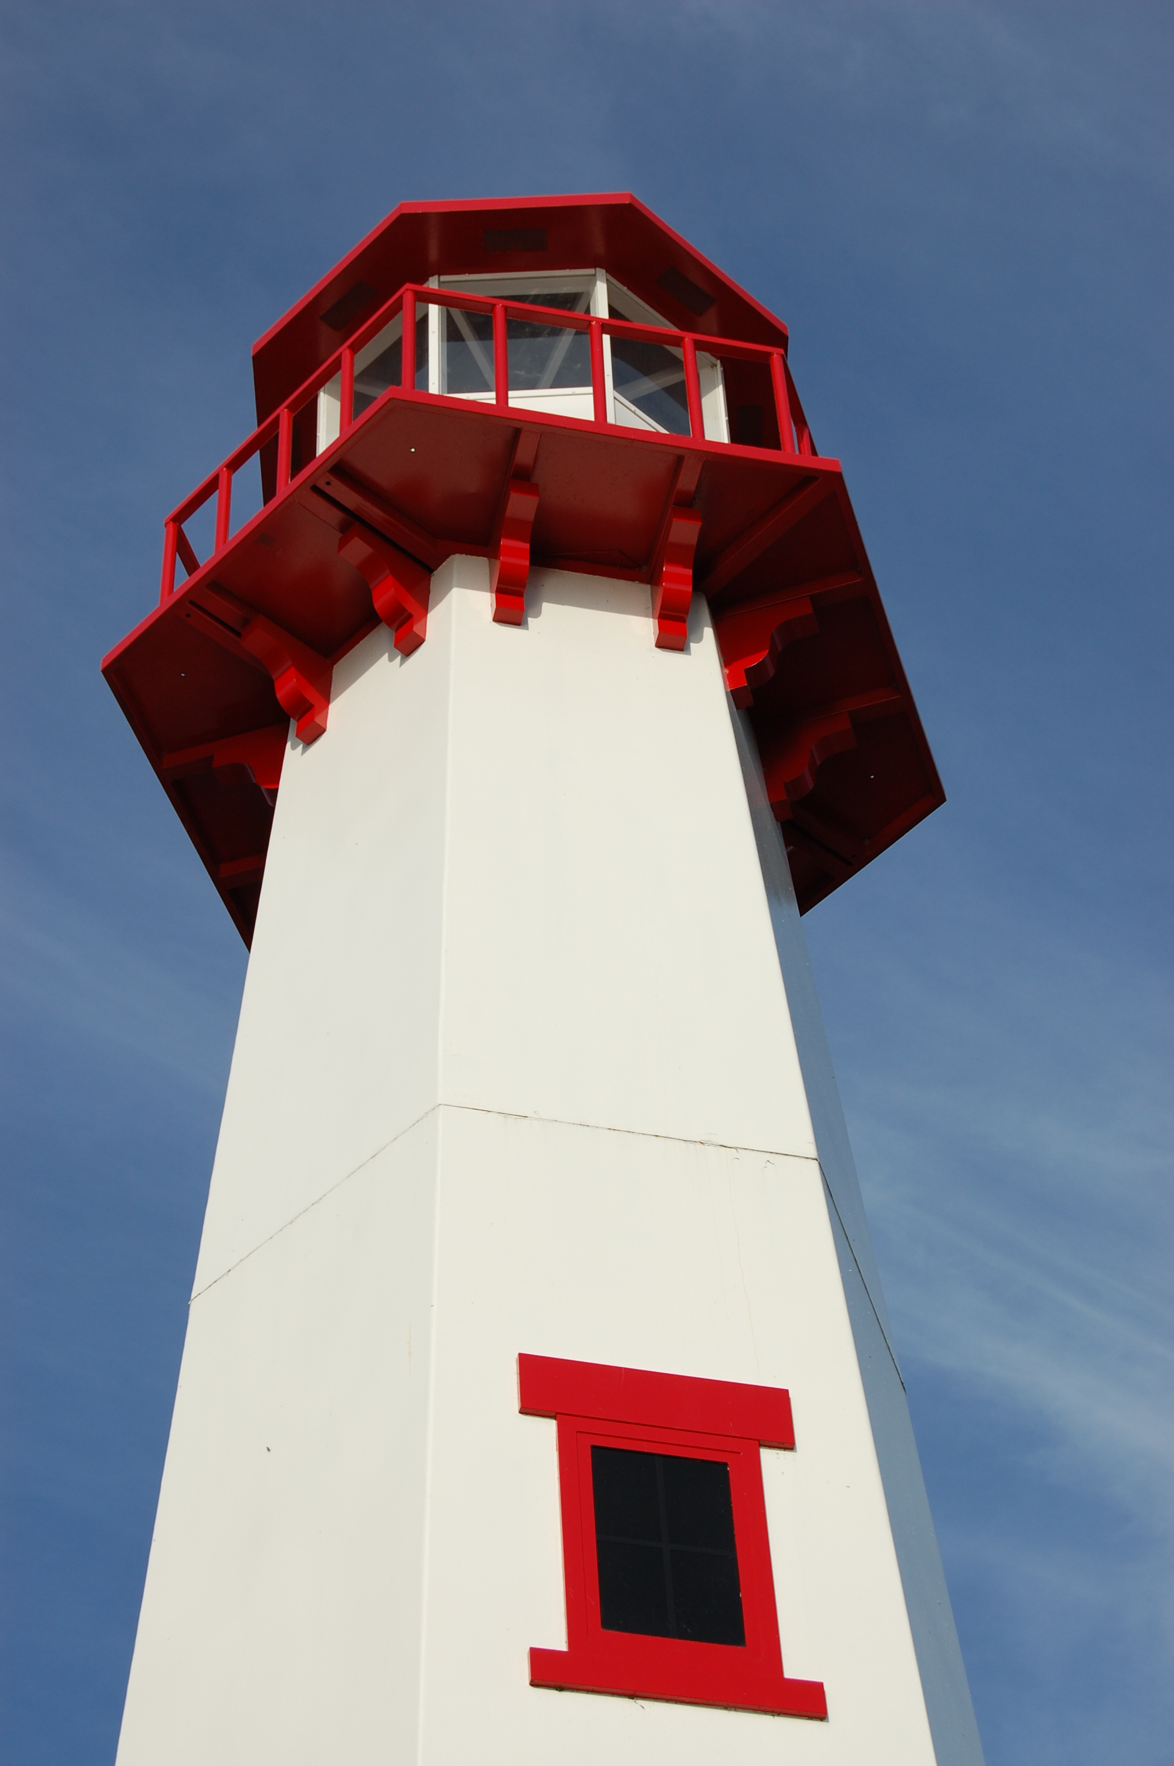
THE LIGHTHOUSE

Newsletter for October 2018

Because I have sinned against him, I will bear the Lord’s wrath, until he pleads my case and establishes my right. He will bring me out into the light; I will see his righteousness. Micah 7:9

Message from our pastor

Dear Brothers and Sisters in Christ,

With summer fading away into fall, activities in our community are beginning to change pace; the traffic is a lot lighter, you can once again make a left turn without waiting what can feel like an eternity, and some businesses are beginning to close for the winter. Life seems to shift gears. Some things slow down and some things speed up. School is back in full swing which brings a flurry of activities from academics, sports, and music events; which is the case in our house. It can be hard to keep track of them all. Life in the church begins to pick up too. Confirmation and Sunday school are beginning. Bible studies are being planned. You can hear the community choir singing in church on Monday nights, and of course we are beginning to make plans for the coming holidays. It’s also a time when we begin to see faces in church that we may not have seen during the summer, due to work or vacation. It’s a time to reconnect with our friends and family in our faith community. It’s also a time when we say good-bye to those who travel south for the winter. Over all, it can be an emotional time. A time when you may find yourself asking the question “How am I going to do it all”?
I have found myself asking that question. That’s when I turn to one of my favorite Psalm, 46:10a “Be still and know I am God”. It is during these busy times I must sit down and just clear my mind. During what can feel like chaos, or that I am being overwhelmed just stop and take a deep breath and pray for peace to center my life in the present with Christ and put the situation in God’s hands, and just quiet the mind.
I encourage you to take a little bit of time in your busy day to just be still. Read a devotion, or a passage in the bible that gives you comfort. In that still moment, ask God for peace in your life in such a busy world.

Yours in Christ,
Pastor David

Newsletter

The October Newsletter was sponsored by
Pega & John Kennedy


In honor of their family

Noisy Offering

The October Noisy Offering will go to Always Being Made New Campaign

Adult Bible Study

Trinity Bible Study will be Tuesdays at 6 pm.

Sunday School


SUNDAY SCHOOL for pre-school to

5th grade students will begin October 21st.

Class will be held during the service.

If you are interested in getting involved,

give Pastor David a call. We look

forward to seeing you soon!!

Women’s Group

On October 14th, the Ladies of Zion will meet after church.

Confirmation

Confirmation will begin on October 21st from 5 to 6:30 pm

Care Committee

The Care Committee is looking for addresses

of college students and members of the military.
They will be sending out “care” packages.
Let Sandy Feleppa know.

Evergreen Living Center

Barb Lehto
Judy Ryerse

Halloween

Halloween is a celebration observed in a number of countries on 31st of October. It begins the three-day observance of
Allhallowtide, the time in the liturgical year dedicated to remembering the dead.

Have a safe and happy Halloween!

Anniversaries in October

October 11 Ray & Shari Baron
27 Dave & Rita LaVake

Birthdays in October

October 1 Dylan Shepard
6 Kristen Olsen
6 Saylor Sorenson
8 Teagan Ferguson
9 Jeff Gamble
18 Bernard Crouch
19 Ray Baron
20 Madison Olsen
22 Katti Gamble
23 Ivan Schlehuber
25 Logan DeKeyser
25 Ken Smith
25 Michael Gustafson (and Lara)
26 Judy Massey
27 Steven Campbell
27 Kristi Gustafson
27 Mike Wilkins
27 Jeanne Rose

Baptismal Anniversaries

October 5 Sara Sorenson
5 Anthony Lester
7 Sarah Doran
11 Nicole Garen
17 Michael Lennington
17 Jim Ryerse
17 Gavin St. Onge
20 Les Therrian
23 Gary Sorenson

24 Gunnar Olsen
25 Jon Olsen
25 Sally Idalski
25 Haley Dodds
27 Andrew Sjogren
27 Jacob Sjogren
28 Denise Maxson

Trinity Worship Families

Oct 7 Kennedy Family
Oct 14 Rose Family
Oct 21 Movalson Family
Oct 28 Baron Family

Zion Funeral Committee Oct - Dec

Team Leader: Lorraine Graham (643-8419)
Co-leader: Betsy Turf (643-1512)

Servants for Zion

Ushers & Greeters

Oct 7 Karen Schlehuber & Marialana Nygard
Oct 14 Alan & Betsy Turf
Oct 21 LaJoice Family
Oct 28 Hilda Ryerse & Lynn Evans

Lectors

Oct 7 Betsy Turf
Oct 14 Richard Galor
Oct 21 Cathie Tielbar
Oct 28 Lorraine Graham

Communion Assistants

Oct 7 Mary Christiansen
Oct 14 Carol Elmblad
Oct 21 Dena Barker

Acolytes

Oct 7 Josh Feleppa
Oct 14 Brendan Insley
Oct 21 Gunnar Olsen

Altar: Karen Schlehuber
Money Counters: Dena Barker & Lana Lennington

The Usher duties are:
- Arrive 30 minutes before church
- Pass out bulletins and welcome guests
- Help with the offering and communion
- Record attendance

Council Meetings

Trinity Council – September 16, 2018 – 6 pm
Zion Council – September 17, 2018 – 6:30 pm

Zion’s Council Members
President: Steve Christiansen 298-1051
Vice-President: Carol Elmblad 630-4380
Co-Treasurers: Dawn Akers 643-7552
Co-Treasurers: Lana Lennington 643-6576
Mary Christiansen 235-6123
Robert Marshall 643-8936
Secretary Dena Barker 430-1460
Emma Feleppa 430-8011
Tammy Shepard 906-984-2064

Trinity’s Council Members
President: Jerri Rose 292-5570
Vice-President Sharon Chalmers 292-5440
Secretary: Tracy Movalson 292-5581
Treasurer: Pega Kennedy 292-5633
Co-Treasurer: Jim Rose 292-5570
Financial Secretary: Tom Gustafson 292-5460
WELCA: Pega Kennedy 292-5633
John Kennedy 292-5633
Lois Movalson 292-5581

Treasurer's Report for Zion
January 1, 2018 through September 19, 2018
Income:
 | Amazon Smile Foundation | 27.67
 | Building | 40.00
 | Church Use Income | 705.00
 | General | 45,639.27
 | Fund Raising | 2,519.77
 | Trinity Share | 9,024.24
 | TOTAL |  | 57,955.95
Expenses:
 | Administration | 4,086.83
 | Benevolence | 339.36
 | Church Maintenance | 10,197.43
 | Education | 645.29
 | Parsonage Maintenance | 2,963.23
 | Pastoral | 36,360.88
 | Worship | 2,552.06
 | --To Building Fund | 0.00
 |  |  | 57,145.08
 |  | Net Income | 810.87
***********************************************************
Thrivent Financial Investment Fund |  |  | 346.64
General fund balance: |  |  | 586.10
Kitchen/Building Fund balance |  |  | 1923.63
General fund owes building fund: |  |  | $ 40.00
General fund owes Mission Endowment fund: |  |  | $ 12,995.00

Zion Lutheran Church

Council Notes for September 19, 2018

Attending Pastor David Tielbar, Carol & Mark Elmblad, Dena Barker, Steve & Mary Christiansen, Dawn Akers, Bob Marshall. Meeting started at 6:40.

Opened with reading of Isaiah 49:16.

Old business discussed and approved.

New water heater put in parsonage. Working great.

Pastor's report: discussed and approved. Pastor will be going to a retreat on February 10th and 11th in Escanaba.

Carol Richel passed away.

Nancy Hardy in Medilodge in Cheboygan.

Dawn's financial report given and approved.

Stewardship discussed. Educating the congregation over the next 6 weeks on Stewardship. Stewardship potluck on October 21st.

Furnace needs fixing. (Burner not firing)

Discussed and approved getting ad in visitor’s magazine. Cost $150.

Bob gave update on lights and fans. Discussed and approved.

Looking into rental on copier and supplies for copier. Less costly.
Ended meeting with Lord's Prayer.

Respectfully submitted by,
Dena Barker

Prayer List

If you would like someone added to the prayer list, please fill out a yellow card or call the church)

Mary Belonga, Dave & Lois Movalson, Barb Lehto, Bev Kammers, Eunice Therrian, Craig Therrian, Shirley Winberg, Richard Galor, Judy Ryerse, Cindy Hendricks, Carol Litzner, Holly Lester, Sandy Huskey, Jim & Jerri Rose, Bill & Sandy Tielbar, Walter & Jane Puccio, Carol & John Watson, Mike & Linda Wilkins, Larry Hopper, David Lloyd, Donna Harju, Tom Beaudoin, Terri Hill, Merlin Doran (Merlin’s father), Gayle Kaminsky Pande, Ann Blaine, Mary Ellen Reavie, Sylvia Richards, Jackie Jacobson, Krista MacArthur, Bill & Ann Anderson, Pastor Joe, Sam, Wes & Dorothy Pechta, Chase Hancock, Jerome Robbins, Carol Richel, Jack & Elsie Dryer, veterans with PTSD, the family & friends of Carol Richel and the family & friends of Nancy Hardy.


Contact Information

Pastor David Tielbar may be reached at 906-984-2051 or at david.tielbar6@gmail.com. In an emergency, you can reach the Pastor’s cell phone at (563) 880-4512

Church telephone: 906-643-7870 - Answering machine
The secretary will usually be in the office on Tuesday and Thursday mornings from 9 – 12

The website is at http://zionstignace.com/home.html
- Find us on facebook at www.facebook.com/zionstignace

Email: ziontrinity950@gmail.com

Zion Evangelical Lutheran Church and Trinity Lutheran Church are congregations of the Northern Great Lakes Synod and the Evangelical Lutheran Church in America.

Trinity’s Sunday Service is at 9 a.m.
Zion’s Sunday Service is at 11 a.m.

ELCA Fall Fest
Quilt and Fine Arts Auction


